Greg Hess

Summer 2018

CSCI 232

Homework 1 - Debugging/Time Complexity/Reading from a file. Due 8:00 AM Wed 5/16/2018

Part 1: Debugging (33 pts)

Q1: When running a debugger in an IDE, what is the difference between step over and step into?  
A: When stepping over the debugger will skip traversing through a function and return with the values from running it – used when you are confident a function or part of code has been properly tested.

Q2: Describe how to run the debugger in your favorite IDE.   
A: Normally you would define break points in your code at logical points where discrete tasks are completed. From there you can simply right click on the package and choose to debug as a Java (or whatever) program.

Q3: Describe when you would use a debugger and when the debugger may not show you a bug in your code.   
A: You would use a debugger when trying to solve an issue where your code stops running due to an error that is not clear enough to fix it based only on the error code given. Debuggers may not work if you are developing a distributed application where there is code that is executing remotely. It also may not work on a compilation error.

Part 2: Time Complexity (33 pts)

Q1: Complete the following quiz. Take the quiz until you get 100% on all of the questions. Please provide a screenshot showing that you received a 100% on the quiz.

* <https://www.khanacademy.org/computing/computer-science/algorithms/asymptotic-notation/e/quiz--comparing-function-growth>
* [https://www.khanacademy.org/computing/computer-science/algorithms/asympto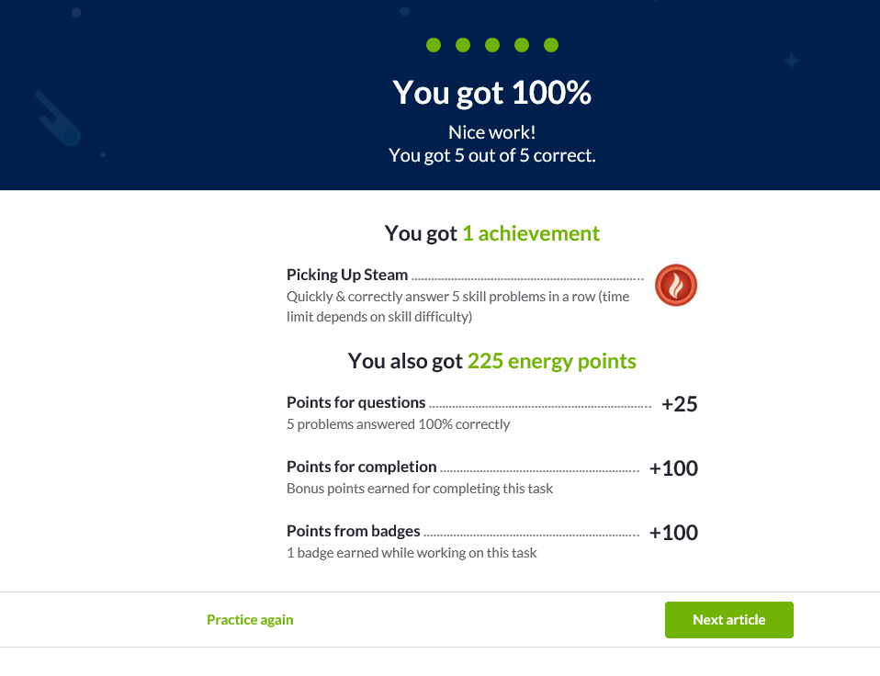tic-notation/e/quiz--asymptotic-notation](https://www.khanacademy.org/computing/computer-science/algorithms/asymptotic-notation/e/quiz--asymptotic-notation)

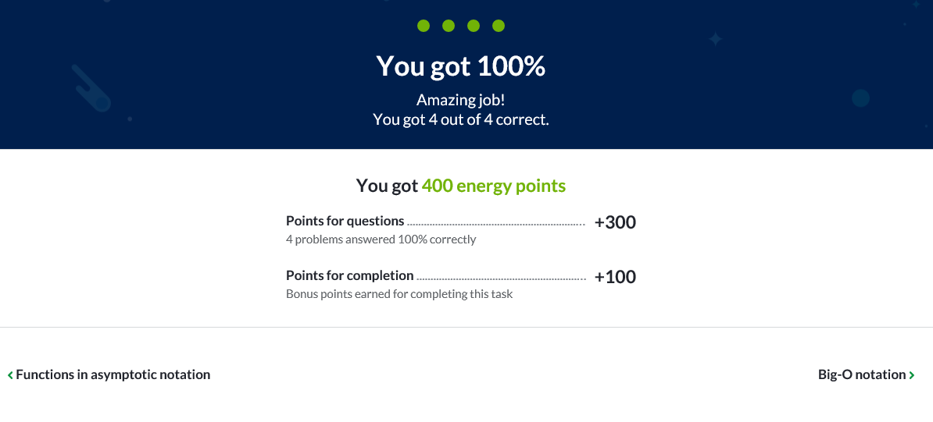

Part 3: Reading in from a file (34 pts)

Review the following documentation:

* <https://docs.oracle.com/javase/tutorial/essential/io/file.html> → This one is used more in industry because of its performance
* <https://docs.oracle.com/javase/7/docs/api/java/util/Scanner.html> → This one is a bit simpler in my opinion

Write a program that reads the contents of a input.txt file and print the contents of each word in its own line. You MAY NOT USE ABSOLUTE FILE PATHS. Absolute file paths will cause your code to FAIL to run on any machine other than yours. Only use relative file paths. Submit your program as either a git repo or zip up the entire project and provide the zipped file. An example output of your program might be:

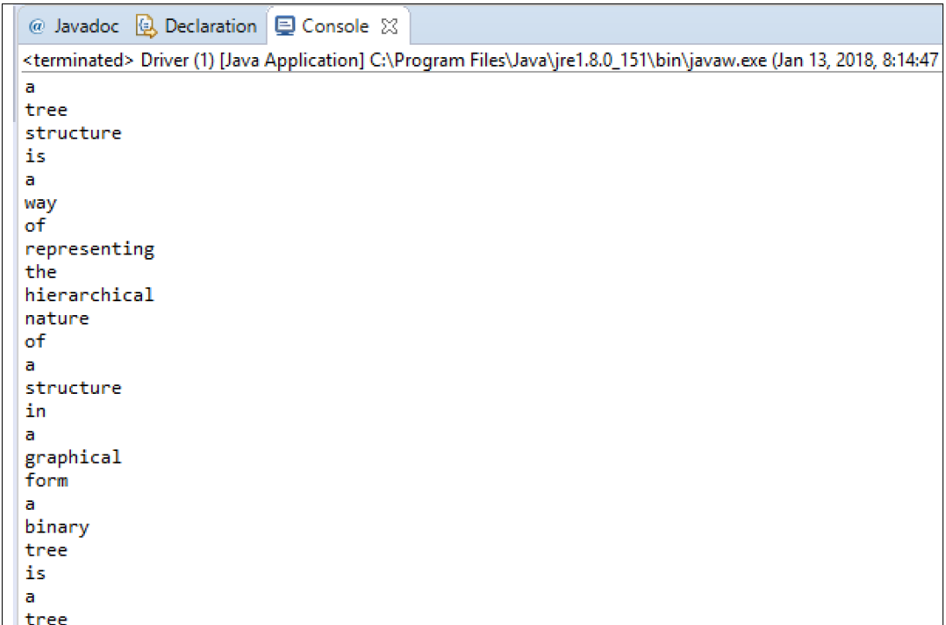

Unfortunately I am having issues with my Eclipse installation and can’t compile. Sorry, I’m the rare exception in CS at MSU in that I’m cyber infrastructure and don’t normally have all the Java development stuff setup and sometimes takes me a while to get my environment setup. Is there any chance I can include in my first programming assignment?